# Assignment -2

Python Programming

|  |  |
| --- | --- |
| Assignment Date | 20 September 2022 |
| Student Name | Mr.R.Ajithkumar |
| Student Roll Number | 621319106003 |
| Maximum Marks | 2 Marks |

# Question-1:

Build a python code, Assume u get temperature and humidity values ( generated with random function to a variable ) and write a condition to continuously detect alarm in case of high temperature.

import random import time while(True):

temp = round(random.uniform(10,50),1) print("Temperature : "+str(temp)) humidity = random.randint(0,100) print("Humidity : "+str(humidity)+"\n") if(temp > 36.5 and temp < 37.5):

print("Low Body Temperature") else:

print("High Body Temperature") if(humidity > 30 and humidity < 60):

print("Low Humidity") else:

print("High Humidity")

if((temp > 36.5 and temp < 37.5) and (humidity > 30 and humidity < 60)):

print("All is good") time.sleep(1)

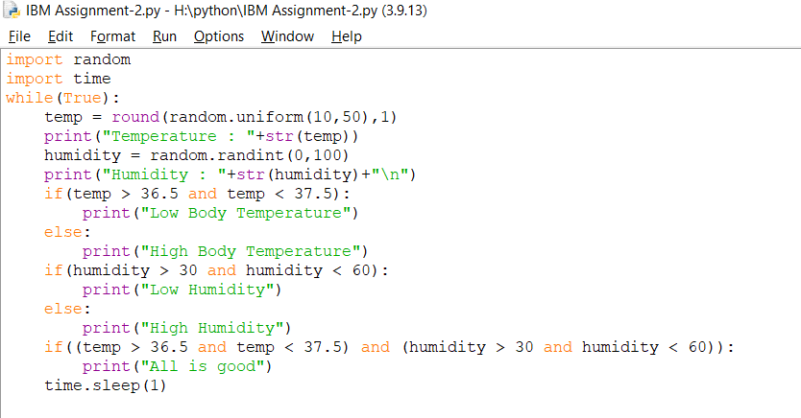**Output :**

